TO: Assembly

FROM: William Brown

RE: Making the Durham Experience Accessible for Commuter Students

DATE: 30 May 2024

Assembly Notes
- In 2022/23, the University reported that 3,382 ‘commuter students’ lived outside of the DH1 postcode area. This equated to 15.3% of the total student body.
- Using a different, more general definition of ‘commuter student’, research also found that Durham is within the bottom 20 universities in the UK for the proportion of the student body that are ‘short distance commuter students’ (i.e. students living within 57-152 miles of their university), with just 1.3% of Durham students falling into the category.
- Other research also identifies that non-commuter students, particularly first year students living in university accommodation, enjoy a ‘perceived fluidity between learning, living and social environments’ with the same space having a multi-purpose use making ‘social interactions less complicated’.
- The research found that this fluidity was in direct contrast to the experiences of students who did not live in university accommodation during their first year. Instead, these students viewed their identity as being split between ‘two worlds’ – their non-student ‘home’ identity, especially where they lived with their own families, and their university identity. This made engaging in the social aspect of university more challenging as it transcended both their two senses of identity, sitting uncomfortably between them.
- It is not unreasonable to suggest that this phenomenon is even more strongly felt at Durham due to Common Rooms and college bars allowing for more organised social events to be held often within the colleges, further combining the ‘social’ and ‘living’ space into one.
- A recent Palatinate investigation found that the University has around 400 unfilled beds in colleges.
Assembly Believes
- Although there is no dispute that commuter students exist as a demographic of students, there is currently no consistent definition for what criteria define a ‘commuter student’. It would be beneficial for Durham SU to adopt a standard working definition.
- The postcode-based working definition used previously by the University is not fit for purpose due to the geographic magnitude of DH1 (see Appendix 1A). Students living in places such as High Shincliffe and Brasside are likely to have an experience more similar to students living outside of DH1 than students living in the City of Durham.
- That the University, SU, and all other relevant parties should do all within their powers to make the ‘Durham experience’, including its social and extra-curricular elements, as accessible as possible for commuter students.
Assembly Resolves
- To adopt the following as a working definition of commuter students:

‘A student living further than a 40 minute walk or 20 minute car-ride from the University and not living with other Durham students’.

- To require the SU to campaign for the introduction of a scheme enabling students that fall within the above definition to rent on an affordable, nightly basis spare beds in their college in order to allow these students to more easily participate in evening/night-time social activities.
- To require the SU to work with the University to ensure that other facilities are provided to make it possible for students to remain on campus for long periods of time between contact hours, maximising accessibility for students who cannot, for whatever reason, feasibly return to their residence during the day.

Appendix 1
- Map of the DH1 postcode area (inside the red dotted line). 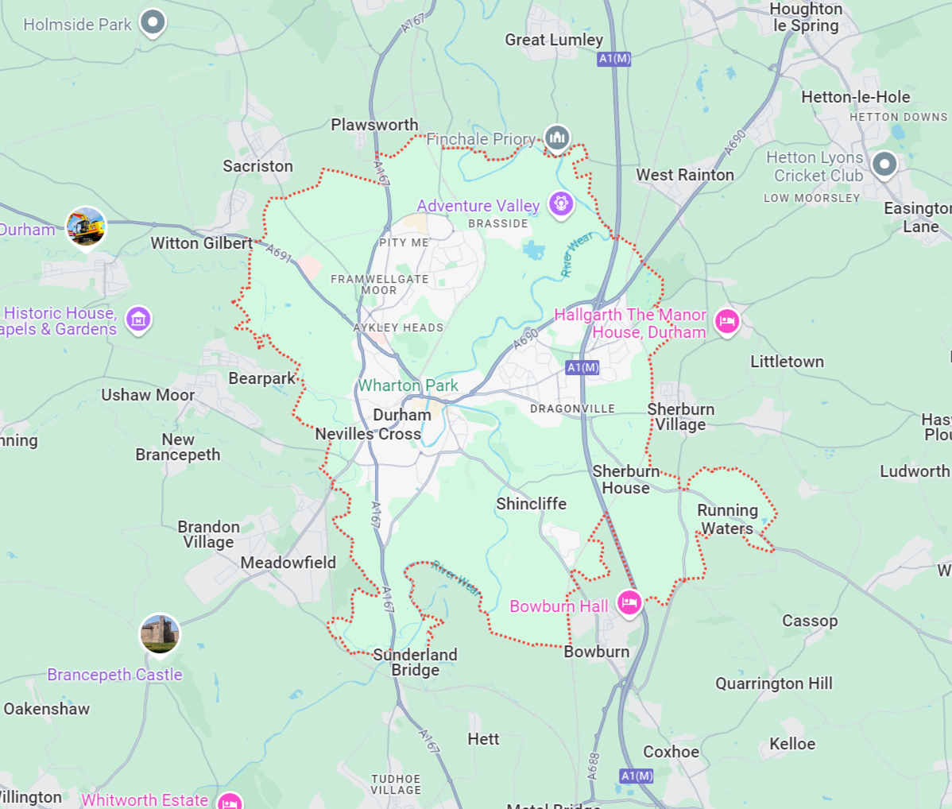

Shepherd, H., ‘Report – Student Accommodation Data Analysis 22/23’, Durham University Housing Strategy Group, 2023, p.3.
Donnelly, M. & Gamsu, S., ‘Home and Away: Social, ethnic and spatial inequalities in student mobility’, The Sutton Trust, 2018, p.31.
Holton, M., ‘Examining students’ night-time activity spaces: identities, performances and transformations’, Geographical Research, 2016, p.8.
Ibid, p.15.
Burrin, E., ‘Almost 400 unoccupied beds in Durham-owned college accommodation’, Palatinate, 2024.

